Connect to Salesforce from Postman with Authorization Code Flow
- Create an External Client App Manager in salesforce:
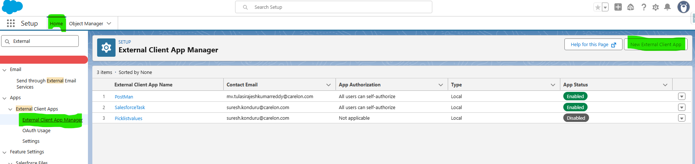

- Fill all required fields and enable the OAuth Checkbox:
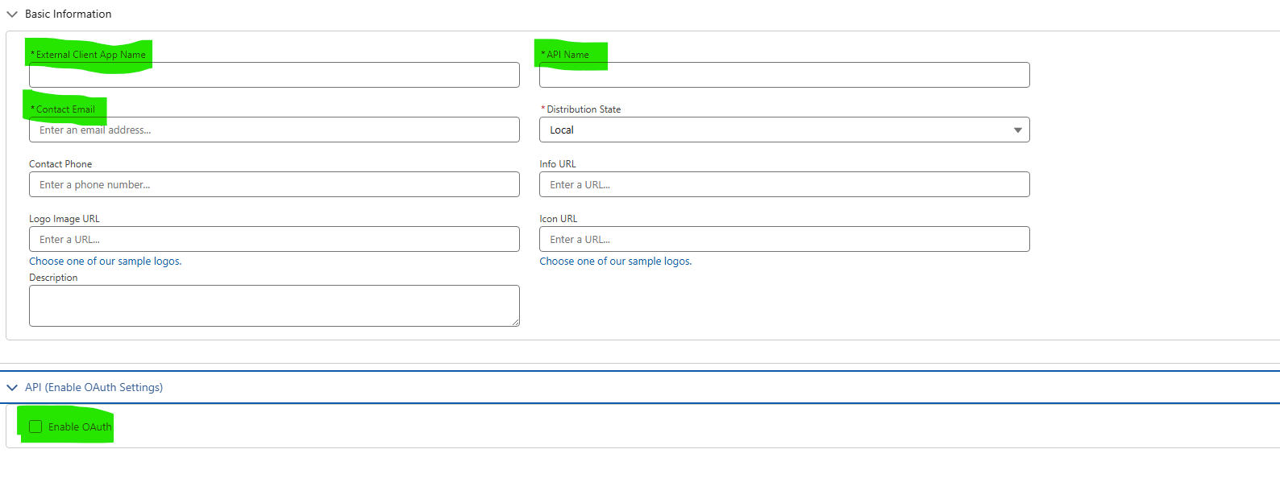
- Add callback url, choose OAuth Scope and Enable Authorization code and Credentials Flow checkbox.
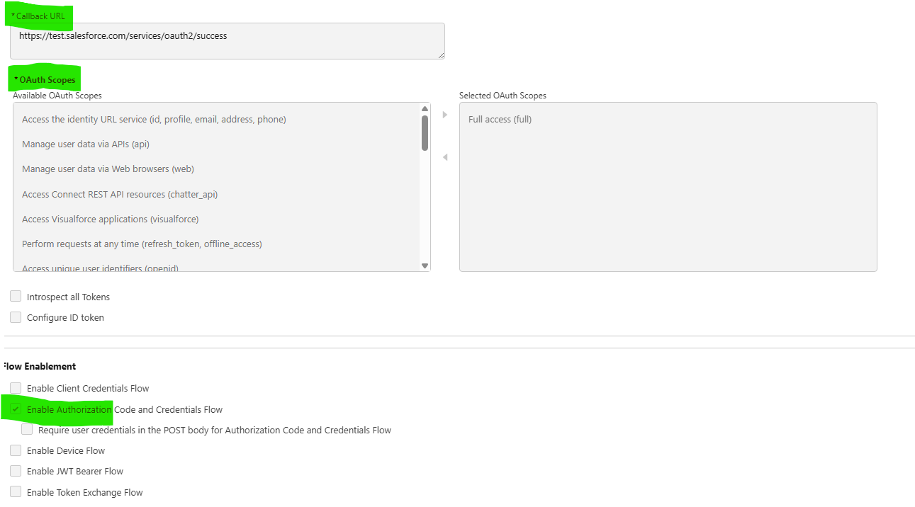
- For Callback URL:
Sandbox: https://test.salesforce.com/services/oauth2/success(callback)
Production: https://login.salesforce.com/services/oauth2/success(callback)
- Click create button to create External Client App Manager.
- After creation, Click Consumer Key button to get consumer key and Consumer Secret
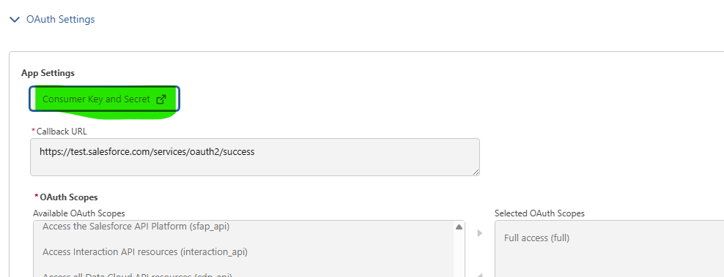
Verify the email with code to view the key and secret.
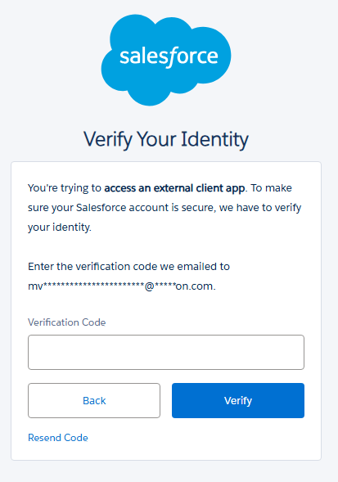
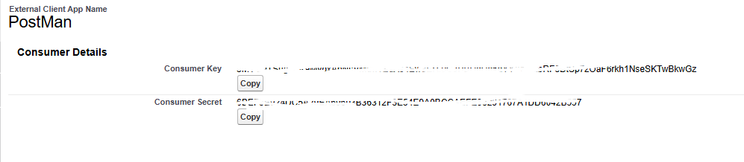
Note the Domain URL from salesforce org.
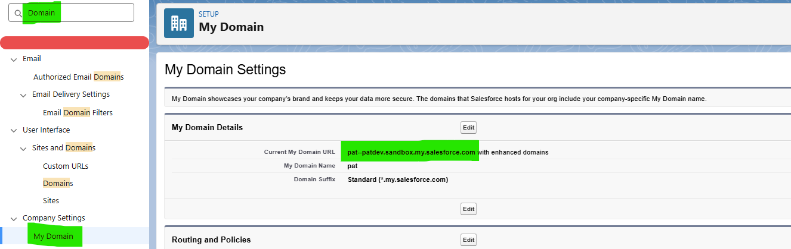

Prepare the web browser url to get temporary code to authorize:
https://{domain_Url}/services/oauth2/authorize?client_id={client_id}&&redirect_uri={callback_url}&response_type=code
Once you open this link in web browser, it will ask to login salesforce account.
After logging into salesforce account with username and password, You will receive the url with code as follows: callback_url}?code=*****************
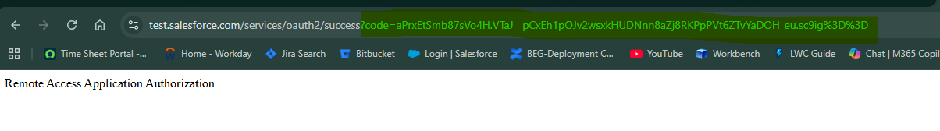
Note the code value separately to get access token from postman tool.
Postman Process:
Open post man tool, add the following details as follows:
  - grant_type: authorization_code,
  - code: copied code from above screenshot
  - client_id: copied consumer key value
  - client_secret: copied consumer secret value
  - redirect_uri: copied callback url
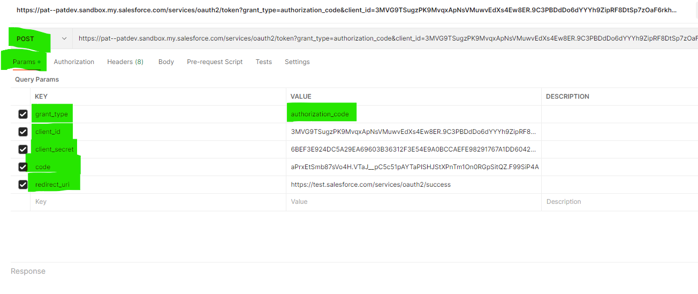
Click send button to get access token value.
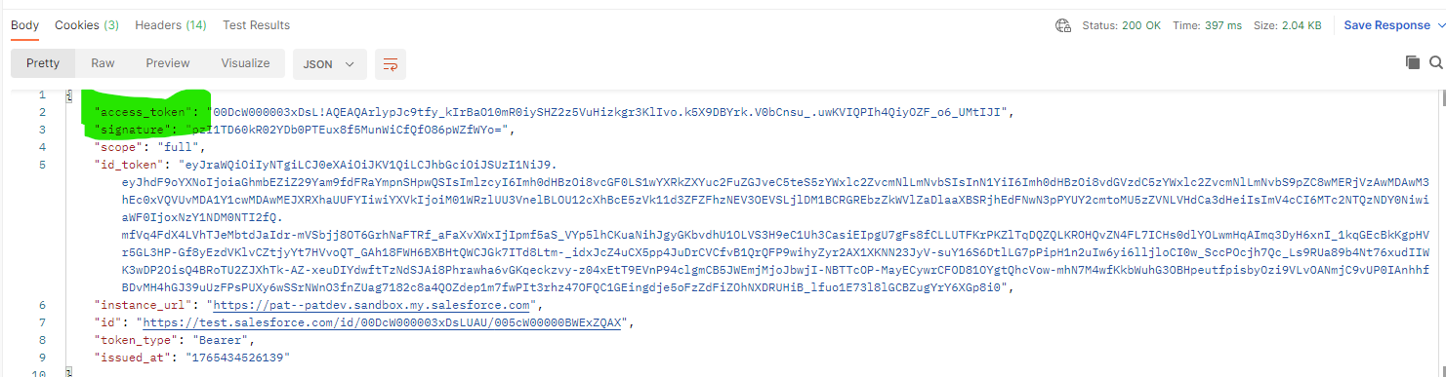

Create a new request with GET method to verify the sales force data with access token as follows:
Method: GET
Url: https://{domain_url}/services/data/vXX.X/limits
Choose Bearer Token from Type field under Authorization tab, Enter the above access token value inside input box. Click Send button to view the salesforce limits from postman tool.
